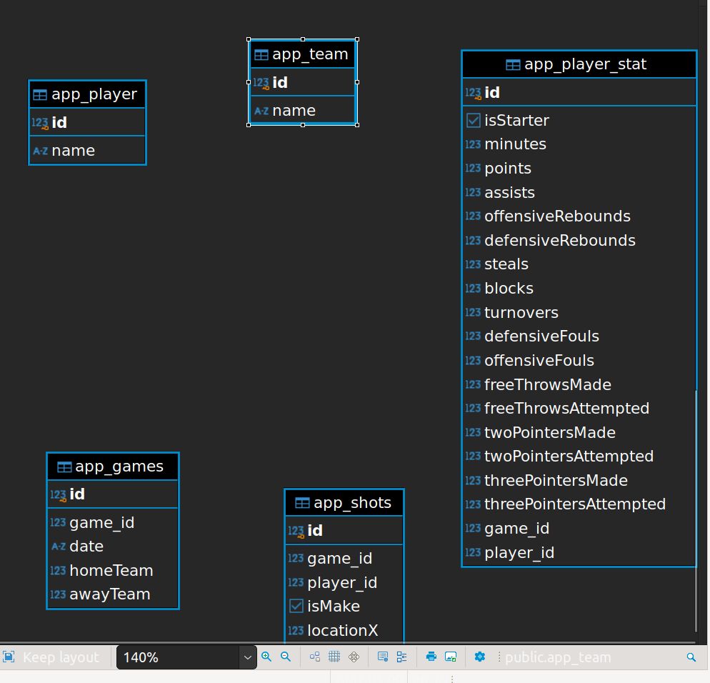

DATA BASE DESIGN

app_player, app_team, app_games, tables have been created based on the entity the player, teams, games. 2 new tables and entities have been added app_player_stat and app_shots to maintain player shot and game stat data both having player_id & game_id as composite primary key.

App_games – game_id is the primary key.  
app_team – id is the primary key

App_player – id is the primary key